Aws Documentation

**Step 1** : Firstly we will create a RDS Database and connect with My SQL Workbench.

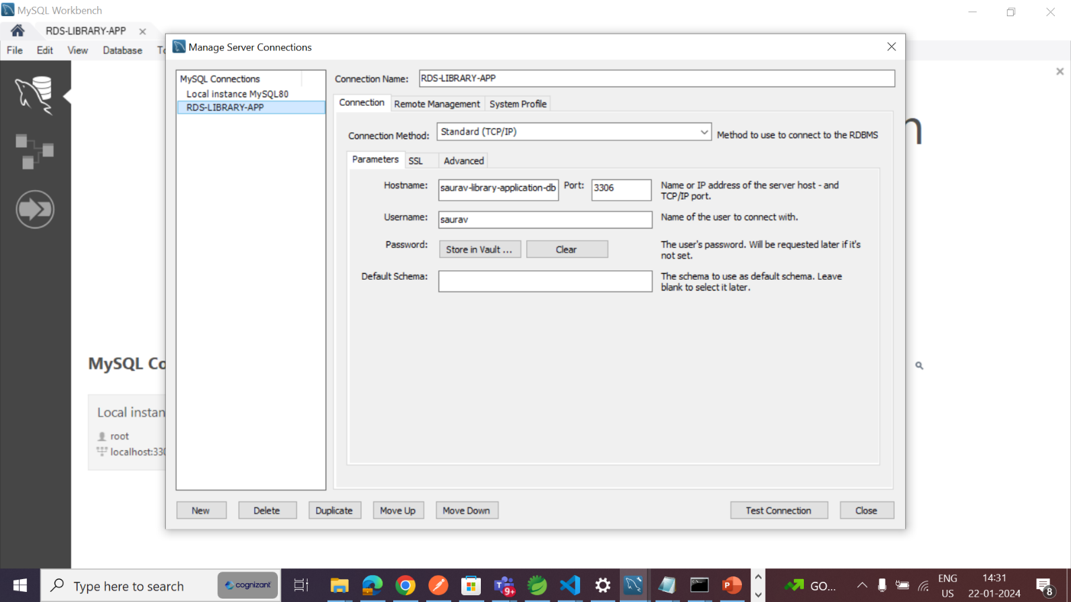

**Step 2** : We will connect our backend code with RDS. We will update the username and password of RDS in our backend’s application.properties file.

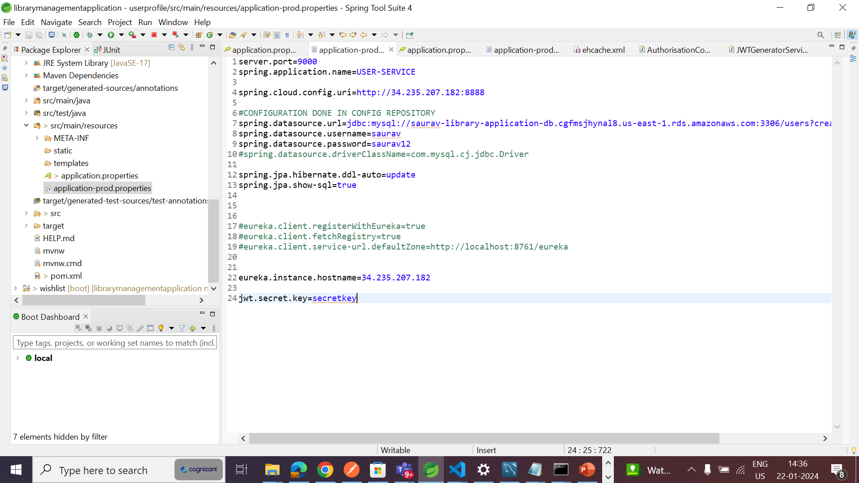



**Step 3** : We will create jars of all the microservices with the help of mvn-clean and mvn-install.

**Step 4** : We will create a EC-2 instance.



**Step 5** : We will instantiate the EC-2 instace and create a elastic ip of the EC-2 instance.

**Step 6** : We will change the ec-2 elastic-ip url with localhost url in the application.properties.



**Step 7** : We will create a S3 Bucket.

**Step 8** : We will create a build folder in S3 Bucket and upload all the jars in the folder.

**Step 9** : We will make a build file of frontend code with the help of ng build --configuration production

**Step 10**: We will upload the dist folder to S3 Bucket.

**Step 11** : We will connect our cmd to ec2 with the help of “ssh -i "libraryapp.pem" [ec2-user@ec2-34-235-207-182.compute-1.amazonaws.com](mailto:ec2-user@ec2-34-235-207-182.compute-1.amazonaws.com)”

**e will run all our jars on the cmd prompt.

**Step 13**: We will open the link of our S3 bucket in the browser.



**Step 14** : Running the url on the browser.

